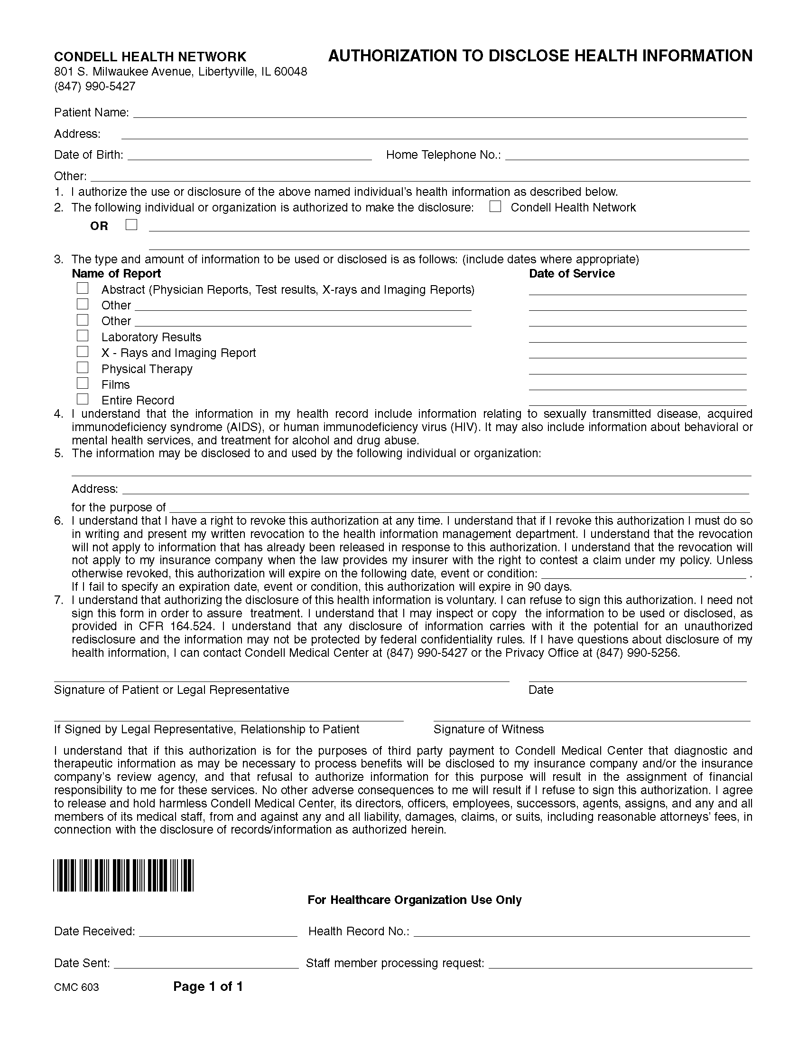
Karen Marcetti
, ,
12/22/1965

X

X

Axiom Requisition Copy Service
2869 Jolly Rd, Okemos, MI 48864 / (877) 886-5090 / Fax (517) 886-4116
legal matter of Marcetti v. Barkel, M.D.

Order No.: 01-12345-003

